METHODS
Selection of MOFA-RNA modality signature genes and Random Forest modelling
The MOFA model was used to derive an RNA-based gene signature, with feature selection guided by the factor loadings of the RNA modality. For each gene, the absolute MOFA loading was calculated, and a series of thresholds was applied. For a given threshold t, all genes with an absolute loading greater than or equal to t were retained and used as input features to train a Random Forest classifier. For each gene set, a Random Forest model was fitted to predict the clinical outcome of interest using the corresponding gene-expression profiles. Model performance was assessed by cross-validation and summarised using the mean area under the receiver operating characteristic curve (ROC AUC) and the mean area under the precision–recall curve (PR AUC). These metrics were compared across thresholds in order to identify the loading cut-off that provided the best predictive performance and to define the final threshold to extract the set of MOFA-RNA signature genes.
Permutation-Based Statistical Validation of Feature Selection
A permutation-based statistical validation analysis was undertaken to evaluate whether the features extracted from the MOFA model with loadings greater than a predefined threshold represented genuine biological signals rather than stochastic or noise-driven associations. A total of 300 independent random permutations were subsequently conducted. For each iteration, the same number of genes were randomly sampled from the complete pool of genes used in the MOFA model and were then used as input features to train a Random Forest classifier. Model performance was assessed through a 3-fold cross-validation procedure, and the Receiver Operating Characteristic (ROC) and the Precision-Recall (PR) curves were generated for each permutation. This validation method enabled comparison between the distribution of permutation metrics derived from random feature sets and those obtained from the true MOFA-derived feature set.

RESULTS
Optimal loading threshold and definition of signature genes
Systematic variation of the MOFA loading threshold revealed a strong dependence of Random Forest performance on the chosen cut-off (Figure 1). Increasing the threshold from 0.6 to 0.8 led to an improvement in mean PR-AUC from 0.58 (RF0.6) to 0.71 (RF0.8), while the mean ROC-AUC increased from 0.80 to 0.85 over the same range. Further tightening of the threshold to 0.9 or 1.0 did not confer additional gains in ROC AUC (remaining at 0.85 and then decreasing to 0.82) and was accompanied by a reduction in PR AUC to 0.70 and 0.64, respectively. Among all candidate models, RF0.8 therefore exhibited the best overall performance, simultaneously achieving the highest PR AUC and the maximal ROC AUC. On this basis, a MOFA loading threshold of 0.8 was selected as the optimal cut-off, and genes with an absolute loading greater than or equal to 0.8 were defined as the RNA signature. In total, 101 genes met this criterion and were carried forward for subsequent statistical validation and downstream analyses.
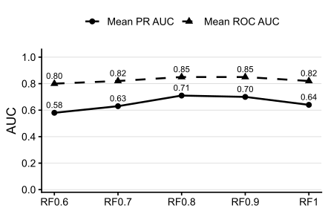
Fig. 1. Performance of Random Forest models trained with MOFA-RNA features selected at different loading thresholds. Each model (RF0.6–RF1.0) was built using genes whose absolute MOFA loading exceeded the indicated cut-off. Mean area under the ROC curve (ROC AUC, dashed line with triangles) and mean area under the precision–recall curve (PR AUC, solid line with circles) were estimated by cross-validation. The model based on a loading threshold of 0.8 (RF0.8) achieved the highest overall performance, with a mean ROC AUC of 0.85 and a mean PR AUC of 0.71, and was therefore selected for definition of the RNA signature.

Permutation-based validation supports the robustness of MOFA-derived features
The robustness of the selected MOFA-derived gene signature was further validated through a 300-run permutation analysis, in which 101 genes were randomly sampled from the transcriptomics modality in the MOFA model in each run, and the performance of the Random Forest classifier was evaluated using a 3-fold cross-validation scheme. The resulting distributions of ROC-AUC and PR-AUC scores showed a marked reduction in predictive performance compared with the model trained on the MOFA-selected features. The mean ROC-AUC across all permutation runs was 0.606, whilst the mean PR-AUC reached only 0.246, with no randomly generated model exceeding the performance of the true feature-based model when considered across both metrics. These results demonstrate that the predictive capability of the 101-gene panel cannot be attributed to random feature selection, but rather reflect a consistent molecular signature associated with radiotherapy response in colorectal cancer.
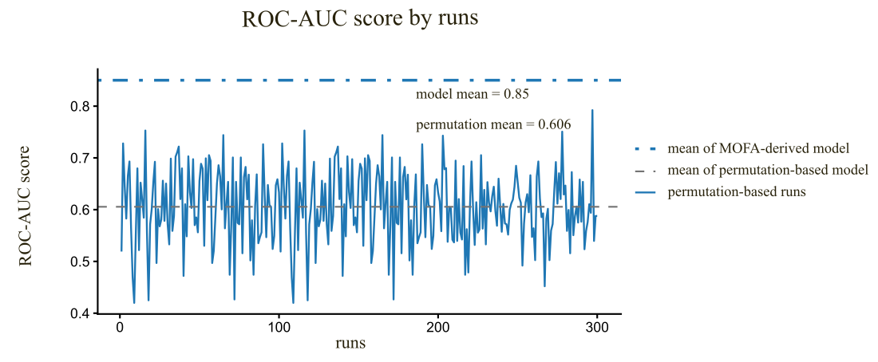
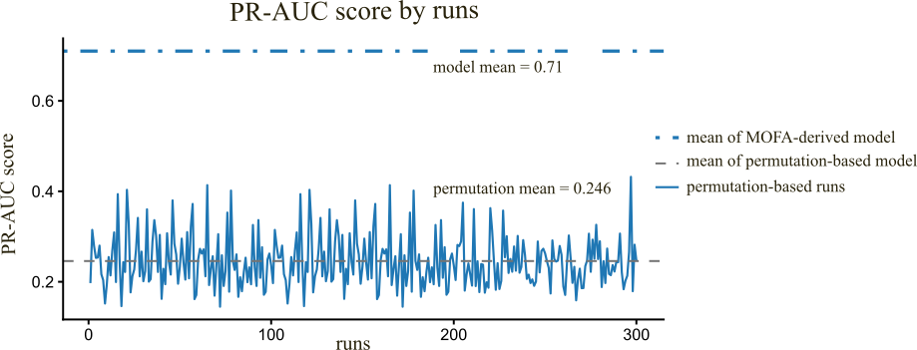
Fig. 2. ROC-AUC scores from 300 permutation runs using 101 randomly selected genes under a 3-fold cross-validation scheme. The dashed grey line shows the permutation mean, and the dotted blue line marks the MOFA-derived model mean (ROC-AUC=0.85). PR-AUC scores from the same permutations. The dashed grey line shows the permutation mean, and the dotted blue line marks the MOFA-derived model (PR-AUC=0.71). None of the permutation models exceeded the true model, supporting the robustness of the 101-gene signature.

Model performance on the SCORT validation dataset
Application of the MOFA loading threshold of 0.8 yielded an RNA feature set that clearly separated complete from incomplete patients in the SCORT cohort (Figure 3.A). Using these genes as predictors in a Random Forest classifier evaluated by three-fold cross-validation, the model achieved a mean ROC AUC of 0.76 and a mean precision–recall AUC of 0.90 (Figure 3.B), indicating that the 0.8-threshold RNA signature retains substantial predictive power in this external dataset.
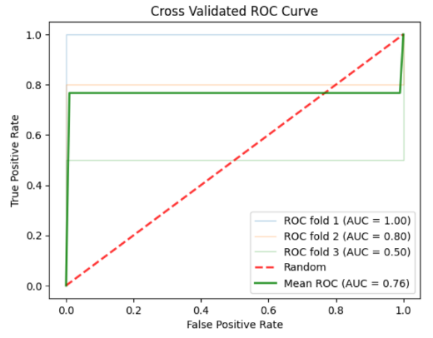 | 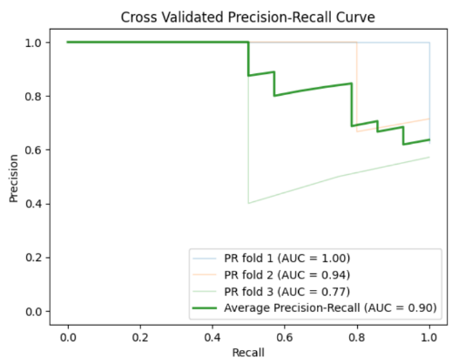
Fig. 3. External validation of the MOFA-RNA signature in the SCORT cohort. (A) Cross-validated ROC curves of a Random Forest classifier trained on genes selected with a MOFA loading threshold of 0.8, yielding a mean ROC AUC of 0.76. (B) Cross-validated precision–recall curves for the same model, yielding a mean PR AUC of 0.90, indicating that the 0.8-threshold RNA signature retains substantial predictive power for discriminating complete and incomplete responders in the SCORT dataset.

